Loan to Directors and Other Entities under the Companies Act 2013

Loan to Directors and Other Entities under the New Regime
Restriction on granting of loan to its directors by a company and other entities in which directors are interested has been one of the most touching issues in the Companies Act, 2013, since 12th September 2013, when Ministry of Corporate Affairs notified 98 Sections of the Companies Act, 2013 to become effective and applicable from that date.
Section 185 of the Companies Act, 2013 which contains provisions dealing with granting of loans & advances and providing of guarantees and securities by a company to its directors and other entities in which directors are interested got notified with effect from 12.09.2013. This section is applicable both to private and public companies. This section in general prohibits a company to grant loans or advances or provide guarantees and securities, in any manner, to its directors or other entities in which directors are interested subject to few exceptions discussed below.
Section 295 of the Companies Act, 1956 contained similar provisions, but with two important differences. One, the Section was not applicable to Private Companies. This meant that Private Company was not governed by the restrictions imposed by Section 295 and was free to grant loans to its directors. Secondly, even in case of public companies, these transactions could be undertaken with the approval of Central Government. But now the situation has changed completely.
LOANS TO DIRECTORS (SECTION 185)
Transactions which are restricted:
- Advancing of any loan, including any loan represented by a book debt, and
- Giving of any guarantee or providing of any security in connection with any loan taken by a director or other person in whom director is interested.

Entities between which the above transactions are prohibited:
A. Company, on one side, and
B. Any one or more of the following on the other side
- any director of the company
- any director of the holding company
- any partner or relative of director of company or holding company
- any firm in which any such director or relative is a partner
- any private company of which any such director is a director or member
- any body corporate at a general meeting of which not less than 25% of the total voting power may be exercised or controlled by any such director, or by two or more such directors together
- any body corporate, the Board of directors, managing director or manager, whereof is accustomed to act in accordance with the directions or instructions of the Board, or of any director or directors, of the lending company.
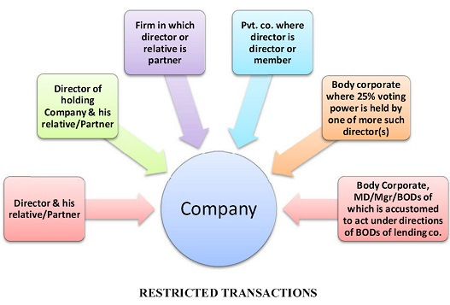

Exceptions to above restrictions:
- Giving of any loan to a managing or whole-time director as a part of the conditions of service extended by the company to all its employees or pursuant to any scheme approved by the members by a special resolution
- A company which in the ordinary course of its business provides loans or gives guarantees or securities for the due repayment of any loan and in respect of such loans an interest is charged at a rate not less than the bank rate declared by the Reserve Bank of India.
Penal Provisions:
Company: | Fine, which shall not be less than Rs. 5 Lakhs but which may extend to Rs. 25 Lakhs.
Director or other person to whom any loan is advanced or guarantee or security is given or provided in connection with any loan taken by him or the other person: | Imprisonment which may extend to 6 months  or  Fine which shall not be less than Rs. 5 Lakhs but which may extend to Rs. 25 Lakhs,  or  Both.

